**SPRINT -3**

**Create a Text to Speech alert and play the alert when the time matches the medicine taking time in CloudantDB and also it sends command “command”:”alert” in IBM IOT watson**

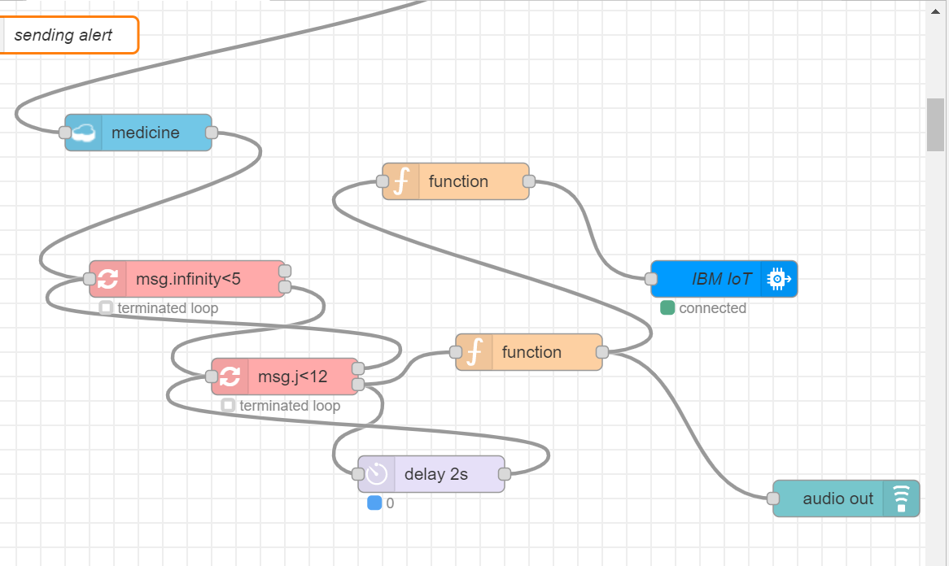

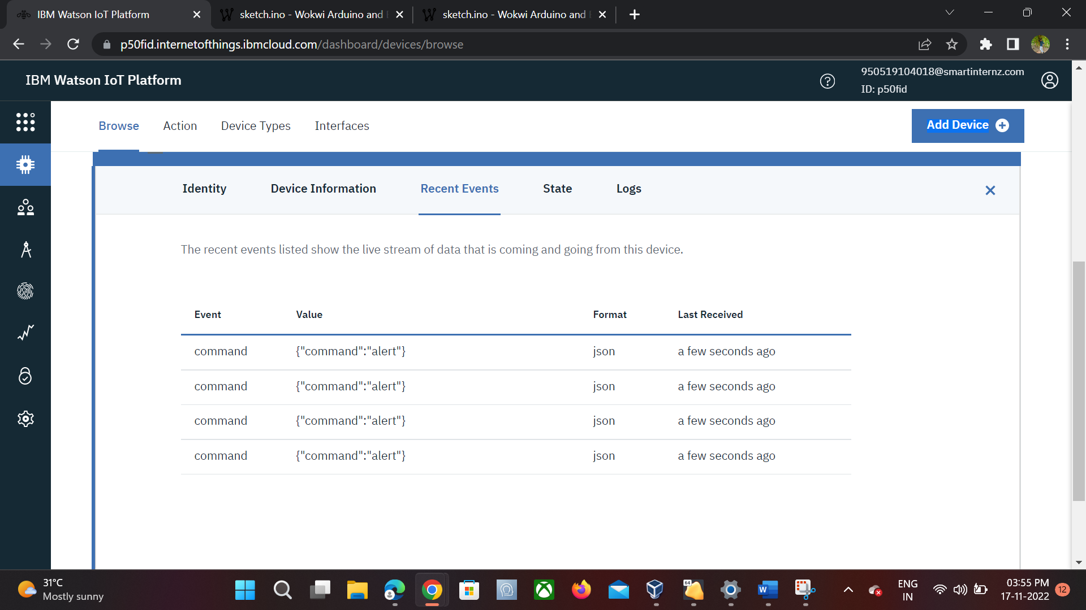

**When alert command is received from IOT Watson the buzzer makes sound**

#include <WiFi.h>//library for wifi

#include <PubSubClient.h>//library for MQtt

#include "DHT.h"// Library for dht11

#define DHTPIN 15     // what pin we're connected to

#define DHTTYPE DHT22

DHT dht (DHTPIN, DHTTYPE);// creating the instance by passing pin and typr of dht connected

void callback(char* subscribetopic, byte* payload, unsigned int payloadLength);

//-------credentials of IBM Accounts------

#define ORG "p50fid"//IBM ORGANITION ID

#define DEVICE_TYPE "abcd"//Device type mentioned in ibm watson IOT Platform

#define DEVICE_ID "1234"//Device ID mentioned in ibm watson IOT Platform

#define TOKEN "12345678"     //Token

String data3;

float v;

//-------- Customise the above values --------

char server[] = ORG ".messaging.internetofthings.ibmcloud.com";// Server Name

char publishTopic[] = "iot-2/evt/Data/fmt/json";// topic name and type of event perform and format in which data to be send

char subscribetopic[] = "iot-2/cmd/command/fmt/String";// cmd  REPRESENT command type AND COMMAND IS TEST OF FORMAT STRING

char authMethod[] = "use-token-auth";// authentication method

char token[] = TOKEN;

char clientId[] = "d:" ORG ":" DEVICE_TYPE ":" DEVICE_ID;//client id

//-----------------------------------------

WiFiClient wifiClient; // creating the instance for wificlient

PubSubClient client(server, 1883, callback ,wifiClient); //calling the predefined client id by passing parameter like server id,portand wificredential

void setup() {

  pinMode(DHTPIN, OUTPUT);

  wificonnect();

  mqttconnect();

}

void loop() {

  wificonnect();

  mqttconnect();

  v = 32;

**Serial**.print("volume:");

**Serial**.println(v);

  //tone(DHTPIN, v);

  delay(1000);

  PublishData(v);

  noTone(DHTPIN);

  delay(1000);

  if (!client.loop()) {

    mqttconnect();

  }

}

void PublishData(float volume) {

  mqttconnect();//function call for connecting to ibm

  /*

     creating the String in in form JSon to update the data to ibm cloud

  */

  String payload = "{\"volume\":";

  payload += volume;

  payload += "}";

**Serial**.print("Sending payload: ");

**Serial**.println(payload);

  if (client.publish(publishTopic, (char*) payload.c_str())) {

**Serial**.println("Publish ok");// if it sucessfully upload data on the cloud then it will print publish ok in Serial monitor or else it will print publish failed

  } else {

**Serial**.println("Publish failed");

  }

}

void mqttconnect() {

  if (!client.connected()) {

**Serial**.print("Reconnecting client to ");

**Serial**.println(server);

    while (!!!client.connect(clientId, authMethod, token)) {

**Serial**.print(".");

      delay(500);

    }

     initManagedDevice();

**Serial**.println();

  }

}

void wificonnect() //function defination for wificonnect

{

**Serial**.println();

**Serial**.print("Connecting to ");

  WiFi.begin("Wokwi-GUEST", "", 6);//passing the wifi credentials to establish the connection

  while (WiFi.status() != WL_CONNECTED) {

    delay(500);

**Serial**.print(".");

  }

**Serial**.println("");

**Serial**.println("WiFi connected");

**Serial**.println("IP address: ");

**Serial**.println(WiFi.localIP());

}

void initManagedDevice() {

  if (client.subscribe(subscribetopic)) {

**Serial**.println((subscribetopic));

**Serial**.println("subscribe to cmd OK");

  } else {

**Serial**.println("subscribe to cmd FAILED");

  }

}

void callback(char* subscribetopic, byte* payload, unsigned int payloadLength)

{

**Serial**.print("callback invoked for topic: ");

**Serial**.println(subscribetopic);

  for (int i = 0; i < payloadLength; i++) {

    //Serial.print((char)payload[i]);

    data3 += (char)payload[i];

  }

**Serial**.println("data: "+ data3);

  if(data3=="alert")

  {

**Serial**.println(data3);

  tone(DHTPIN,32);

  delay(100);

  noTone(DHTPIN);

  }

  else

  {

    noTone(DHTPIN);

  }

data3="";

}

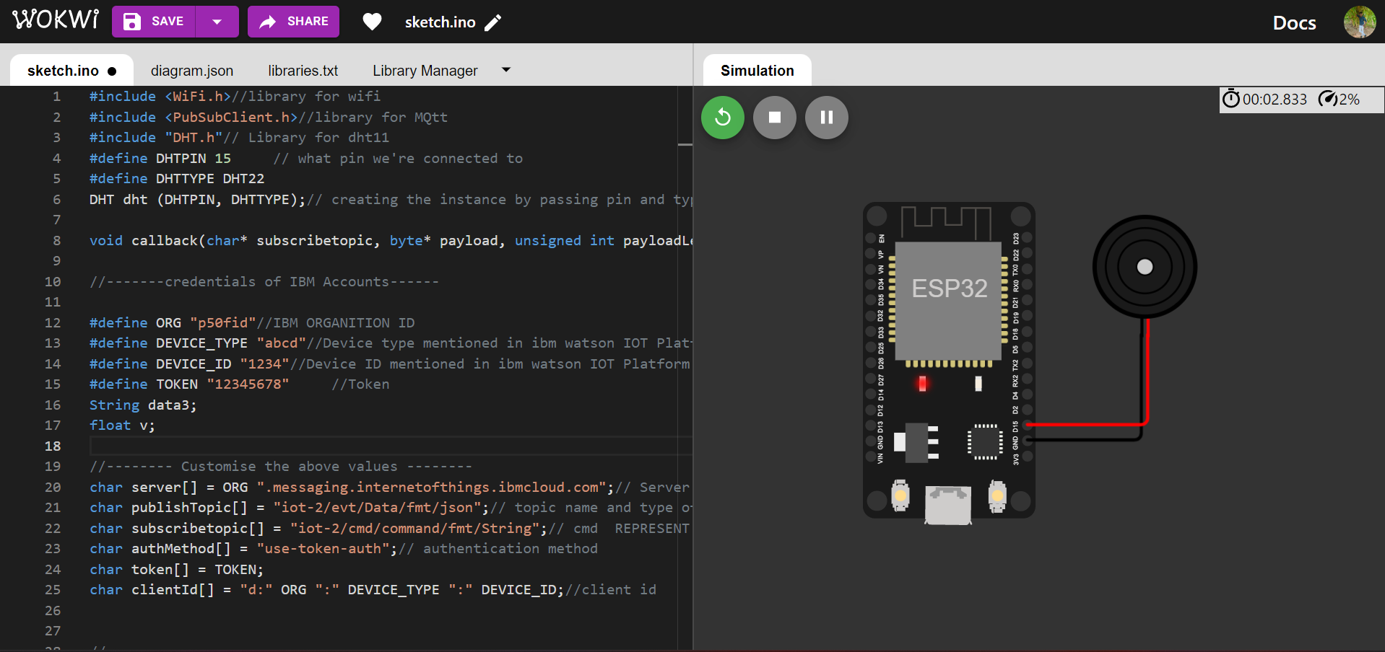

**Once Buzzer plays the event will send to IBM IOT Watson**

